SRF Vacation Scholarship report 2018

The form below should be completed by the student, then forwarded to the supervisor for approval and submission to srf@conferencecollective.co.uk within 8 weeks of completing the project. Please submit the form as a Word document.

A maximum of one figure (with legend of less than 100 words) may be appended if required.

Please note: excerpts from this form may be published on the SRF website, so please ensure content is suitable for website publication, and does not compromise future dissemination of data in peer-reviewed papers etc. The SRF reserves the right to edit responses to ensure suitability for publication on the website, newsletter or in promotional material.

Student’s Name: | Gabrielle Oxley | Student’s Institution/University: | University of Durham
Degree Title and year of study: | BSc Biomedical Sciences. 3rd Year.
Supervisor’s Name: | Dr Suzanne Madgwick | Supervisor’s Department and Institution: | Institute of Cell and Molecular Biosciences, Medical School. Newcastle University.
Project Title: | Prolonging prometaphase in meiosis I mouse oocytes to prevent aneuploidy

Briefly outline the background and aims of the project (max 200 words)
Through cell division a number of key cell cycle proteins regulate alignment. These proteins are required at specific times through prometaphase and metaphase and their destruction must be highly ordered to enable swift and successful anaphase. The major activity regulating cell division is cyclin B1:CDK1, the maintenance of this activity is vital during prometaphase to ensure complete chromosome alignment. Upon alignment, cyclin B1 destruction inactivates CDK1 and triggers anaphase. Cyclin B1:CDK1 activity must be maintained for minutes in mitosis, however this same process requires several hours in human oocyte meiosis. This stage of the cell cycle frequently fails in human oocytes leading to aneuploidies: the leading genetic cause of miscarriage. Like humans, mouse oocytes also require several hours to assemble their chromosomes. However, we find that cyclin B1:CDK1 activity is prolonged in mouse oocytes to support the long chromosome alignment process: consequently, aneuploidy is rare in mouse oocytes. Our aim was to explore the mechanisms of cyclin B1:CDK1 activity maintenance in mouse oocytes, to determine the significance of prolonged cyclin B1:CDK1 activity and to demonstrate how the loss of prolonged cyclin B1:CDK1 activity negatively impacts cell division. This may aid the search for the origin of errors in human oocytes.

Did the project change from that proposed in the application? If so, what changes were made and why? (max 100 words)
Most of the experiments carried out built upon the work of Dr Madgwick in documenting cyclin B1:CDK1 activity regulation in mouse oocytes. Over summer, I carried out the proposed experiments quickly and successfully. This then gave us time to begin preparing and cloning new constructs with which to begin to pinpoint the localization of key activities through meiosis I in mouse oocytes, a main future aim of the lab.

What were the main results/findings of the project? (max 300 words)
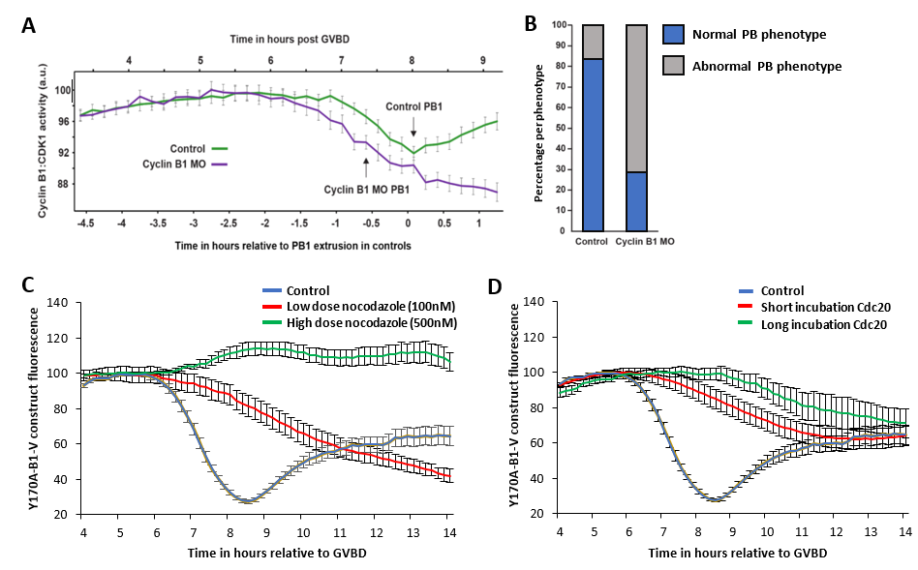
Figure 1.
A) Cyclin B1:CDK1 activity relative to PB1 (first polar body) extrusion in control oocytes and oocytes depleted for cyclin B1.
B) Percentage of normal and abnormal PB phenotypes in control oocytes and oocytes depleted for cyclin B1.
C) Free cyclin B1 (Y170A-B1-V) fluorescence relative to GVBD time with low and high dose nocodazole.
D) Y170A-B1-V fluorescence relative to GVBD time following either a short or long incubation period with a Cdc20 MO as indicated.
Note that PB1 extrusion in oocytes denotes cytokinesis and occurs 10-15 minutes after anaphase.

We found that although cyclin B1 is present in excess of CDK1, when we depleted cyclin B1 in oocytes using a morpholino oligo, cyclin B1:CDK1 activity was lost earlier than in control oocytes (Fig 1A). This resulted in premature anaphase and increased incidence of abnormal cell division, including aneuploidies (Fig 1B).

We hypothesized that cyclin B1:CDK1 activity is maintained in oocytes for a prolonged period of time because the excess of free cyclin B1 is destroyed first in prometaphase, ahead of CDK1-bound-cyclin B1. To determine whether or not the excess of free cyclin B1 could be a genuine prometaphase destruction target, we used a cyclin B1 construct designed to report the destruction of free cyclin B1; Y170A-B1-V cannot bind CDK1. After microinjecting oocytes with Y170A-B1-V message, we recorded the destruction of the expressed protein following two treatments designed to arrest oocytes in prometaphase: checkpoint stimulation using nocodazole and Cdc20 depletion using a morpholino oligo.

Cyclin B1 destruction is Cdc20-dependent and relies on the absence of the checkpoint. When we stimulated a checkpoint with nocodazole to inhibit Cdc20-dependent degradation, CDK1-bound-cyclin B1 degradation is inhibited, however, free cyclin B1 degradation still takes place. Increasing the dose of nocodazole completely inhibited free cyclin B1 destruction. This implies that free cyclin B1 destruction is responsive to the strength of the checkpoint (Fig 1C).

Similarly, when we blocked oocytes in prometaphase with a Cdc20 MO to deplete Cdc20 levels, again, we found that CDK1-bound-cyclin B1 degradation was completely inhibited, yet, free cyclin B1 destruction was still destroyed (albeit at a reduced rate). By extending the incubation period to further deplete Cdc20, we found that we could reduce the rate of free cyclin B1 destruction even further. This demonstrates that the rate of free cyclin B1 destruction is also responsive to oocyte Cdc20 levels (Fig 1D).

What do you conclude from your findings? (max 150 words)
Cyclin B1 depletion allows premature destruction of CDK1-bound-cyclin B1, reducing CDK1 activity and initiating precocious anaphase; this results in abnormal cell division. We suggest that oocytes contain an exact amount of excess cyclin B1 which enables prolonged CDK1 activity, preventing aneuploidy.

We found that free cyclin B1 is degraded in preference to CDK1-bound-cyclin B1 in prometaphase while the checkpoint is still active and Cdc20 is less available. However, this destruction is dose dependent suggesting that perhaps the rate of free cyclin B1 destruction may increase through prometaphase as checkpoint activity diminishes.

In summary, we concluded that an excess of free cyclin B1 is purposefully gradually destroyed through prometaphase in mouse oocytes. We suggest that this is necessary for the prolonged period of CDK1 activity. When we reduce the amount of free cyclin B1, CDK1 activity is lost prematurely and the oocyte appears unable to perform chromosome alignment successfully before division.

How has this experience influenced your thinking regarding your future/ongoing studies, and/or career choice? (max 150 words)
The opportunity to work in a research environment on a cutting-edge project has influenced me to carry out further studies and has helped me decide to pursue a career in research. Also, through working in this area I have established a new-found interest in reproductive biology: an area in which I wish to expand my knowledge through further studies. While working in the lab, I have gained new and important skills that have given me the confidence to pursue a research career and motivated me to develop a career where I can excel in my field.

Please use the space below to add any other comments/thoughts about the SRF Vacation Scholarship (max 100 words)
Student: I would like to personally thank the SRF for the opportunity to carry out this studentship as I believe it has helped build confidence in the lab and allowed me to gain vital experience in important laboratory skills.

Supervisor: Gabrielle has been an excellent, hardworking student. She engaged with great interest in all aspects of the project. She was able to confidently carry out benchwork independently and present her work in a group seminar. I have been impressed with her conduct and ability. I wish her the very best of luck. I’m sure she will do very well in her future.

