SRF Vacation Scholarship report 2018

The form below should be completed by the student, then forwarded to the supervisor for approval and submission to srf@conferencecollective.co.uk within 8 weeks of completing the project. Please submit the form as a Word document.

A maximum of one figure (with legend of less than 100 words) may be appended if required.

Please note: excerpts from this form may be published on the SRF website, so please ensure content is suitable for website publication, and does not compromise future dissemination of data in peer-reviewed papers etc. The SRF reserves the right to edit responses to ensure suitability for publication on the website, newsletter or in promotional material.

Student’s Name: | Imogen Nichols | Student’s Institution/University: | University of Bristol
Degree Title and year of study: | (BSc) Biochemistry, third year
Supervisor’s Name: | Dr Binyam Mogessie | Supervisor’s Department and Institution: | The School of Biochemistry, University of Bristol
Project Title: | Dissecting the function of nuclear actin in mammalian oocytes

Briefly outline the background and aims of the project (max 200 words)
Mammalian oocytes undergo meiosis to mature into egg cells; however, from this division aneuploidy can arise from chromosome segregation errors. This aneuploidy can result in embryo death or genetic disorders in humans, indicating the importance of accurate meiosis.
Actin has been previously shown to have a crucial role in accurate chromosome segregation (Mogessie and Schuh, Science, 2017), aiding in oocyte spindle positioning and vesicle transport (Azoury et al., 2008; Holubcova et al., 2013; Pfender et al., 2011; Schuh, 2011; Schuh and Ellenberg, 2008). Actin filaments are also shown to associate with the meiotic spindles to protect the cells from aneuploidy (Mogessie and Schuh, 2017). Nuclear actin specifically is shown to mediate chromatin organisation in the early mouse embryo (Baarlink et al., 2017) however, it is unknown whether it is required for accurate mammalian meiosis in oocyte maturation.
This led to the project aims of identifying the presence of nuclear actin within mouse oocytes; via phalloidin, an actin chromobody and utrophin directed to the nucleus, and characterising its function during meiosis via TRIM-Away.
Did the project change from that proposed in the application? If so, what changes were made and why? (max 100 words)
Originally the project proposal included the expression of a fluorescent nuclear actin nanobody, however, within the time frame of the scholarship, positive clones needed to produce nuclear actin nanobody mRNA in vitro could not be obtained. A GFP-tagged utrophin domain fused to a nuclear localisation signal was used instead. Owing to time constraints, we were also unable to perform loss-of-function assays using the TRIM-Away method of rapid protein degradation.
What were the main results/findings of the project? (max 300 words)
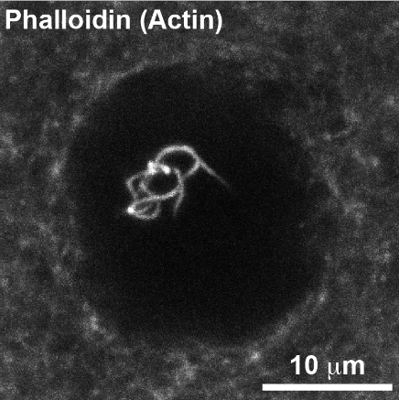
In this project, mouse oocytes that were arrested in prophase and contained a nucleus were stained with Phalloidin to label actin filaments. These were then imaged in three-dimensions using a high-resolution confocal microscope. Acquired Z-stack images were subsequently analysed with IMARIS software to observe the nucleus and actin filaments in three dimensions. Utilising the Z-stack, it was observed that actin filament bundles were present within the nucleus of the oocytes, as seen in Figure 1.
Figure 1- Mouse oocyte nucleus stained with phalloidin, revealing nuclear actin presence by high resolution confocal microscopy.
Subsequently, to confirm this finding in living oocytes, GFP-tagged utrophin, which reproducibly labels actin filaments in oocytes, was cloned with an NLS (nuclear localisation signal). mRNA encoding this probe was then produce by in vitro transcription and microinjected into the mouse oocytes for high-resolution live cell imaging. 4D image analysis of these oocytes then indicated the presence of actin in the nucleus, supporting the findings from phalloidin staining. However, there was also apparent binding of this tagged protein to areas of the oocyte outside of the nucleus, suggesting further optimisation of the NLS sequence is needed.

What do you conclude from your findings? (max 150 words)
With the collective image analysis from phalloidin staining and utrophin-NLS expression in mouse oocytes, there appears to be nuclear actin present. However, further action needs to be taken to support this preliminary finding; including the cloning of the chromobody for use, and optimisation of the NLS cloned with utrophin. The utrophin-NLS expression would also be optimised with simultaneous expression of nuclear lamin binding nanobody, to label the oocyte nuclear membrane and the actin within.
In order to identify whether this observed nuclear actin has a function in mammalian meiosis, and if so what this particular function is, TRIM-Away degradation of nuclear actin should be conducted to observe the subsequent effect on the mouse oocyte maturation.

How has this experience influenced your thinking regarding your future/ongoing studies, and/or career choice? (max 150 words)
This was a very influential project for me. I highly enjoyed my time in the laboratory and the experience it gave me with practical techniques I hadn’t come across before in my degree. This aided me in deciding to switch onto the MSci course, allowing for me to have an extended practical project in my fourth year. The most invaluable knowledge this project provided me with was how to handle the next steps when the experiment doesn’t go as planned. This has given me a true insight into what skills are required for working in research, to which I am now considering as a career prospect.

Please use the space below to add any other comments/thoughts about the SRF Vacation Scholarship (max 100 words)
Student: I greatly appreciate this scholarship enabling me to develop my laboratory skills and understanding of what conducting research is like as part of an institution. Thank you very much SRF for providing me with the ability to undertake this project.
Supervisor: We are grateful to the SRF for this generous support. This vacation scholarship was highly beneficial to my lab because it allowed us to host Imogen, to perform key experiments and generate preliminary data that will form the basis for further projects in the lab. Working with Imogen over the summer has also allowed me to gauge the quality of Bristol Biochemistry undergraduate students, which she has benchmarked as highly intelligent. I will be looking to recruit similarly motivated young talents through this scheme over the coming years.

