SRF Vacation Scholarship report 2018

The form below should be completed by the student, then forwarded to the supervisor for approval and submission to srf@conferencecollective.co.uk within 8 weeks of completing the project. Please submit the form as a Word document.

A maximum of one figure (with legend of less than 100 words) may be appended if required.

Please note: excerpts from this form may be published on the SRF website, so please ensure content is suitable for website publication, and does not compromise future dissemination of data in peer-reviewed papers etc. The SRF reserves the right to edit responses to ensure suitability for publication on the website, newsletter or in promotional material.

Student’s Name: | Magdalena Matkovic | Student’s Institution/University: | The University of Edinburgh
Degree Title and year of study: | BSc Biomedical Sciences, 3rd year
Supervisor’s Name: | Professor Norah Spears | Supervisor’s Department and Institution: | Biomedical Sciences, The University of Edinburgh
Project Title: | The effect of Benzo[a]pyrene on germ cell proliferation in the developing ovary

Briefly outline the background and aims of the project (max 200 words)
Female gamete formation begins in early pregnancy and involves an initial proliferation phase, followed by meiosis. By the end of pregnancy, all germ cells in the fetal ovary will have become enclosed in follicles. Disruption to any of the above processes could thus lead to a reduction in the size of the ovarian reserve, negatively affecting future fertility.

Benzo[a]pyrene (B[a]P), a polycyclic aromatic hydrocarbon found in cigarette smoke, grilled foods and coal tar, has been found to decrease the number of primordial follicles in the developing mouse ovary, however the exact mechanism of action is unknown. Investigating this process is of particular importance as 10-17% of pregnant women in the UK are known to be smokers. Therefore, the aim of this project was to establish whether B[a]P’s effect on newly formed follicles might be via a disruption of germ cell proliferation.
Did the project change from that proposed in the application? If so, what changes were made and why? (max 100 words)
The project followed the methods as proposed in the application. However, in addition to investigating whether B[a]P reduces germ cell proliferation rate in the fetal ovary, we also looked at the total number of germ cells in the ovary following B[a]P treatment.
What were the main results/findings of the project? (max 300 words)
Embryonic mouse ovaries at embryonic day 12.5 (E12.5) and E13.5 were cultured for 24 hours with B[a]P and BrdU, a thymidine analogue which incorporates into the DNA of proliferating cells, added for the duration of the culture. Immunohistochemistry was then carried out on the cultured ovaries for BrdU, to identify cells that had undergone proliferation, and DDX4, to identify germ cells; DAPI was used as a general cell marker. Analyses determined the total number of germ cells in the ovary and the percentage of these that had undergone proliferation during the culture period.

B[a]P had no effect on germ cell proliferation in the developing mouse ovary at either E12.5 (treatment group: 90.1% vs control: 88.3%; p=0.3919, n=12) or E13.5 (treatment group: 67.5% vs control: 70.1%; p=0.7292, n=13).
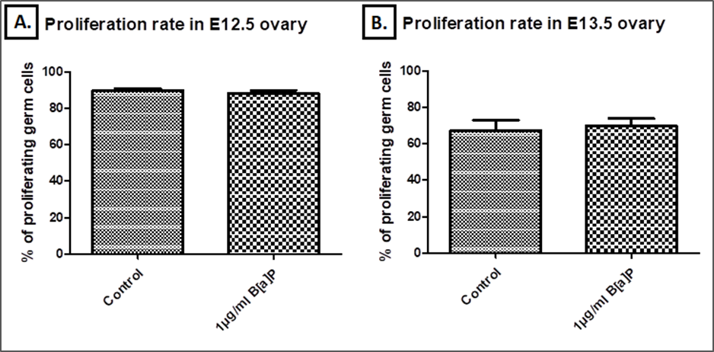
Figure 1. Germ cell proliferation in the developing mouse ovary at A) E12.5 B) E13.5.

Additionally, B[a]P did not affect the total number of germ cells either at E12.5 (treatment group:
2323 vs control: 1499; p=0.0662, n=12) or E13.5 (treatment group: 3767 vs control: 3538; p=0.7016, n=13).
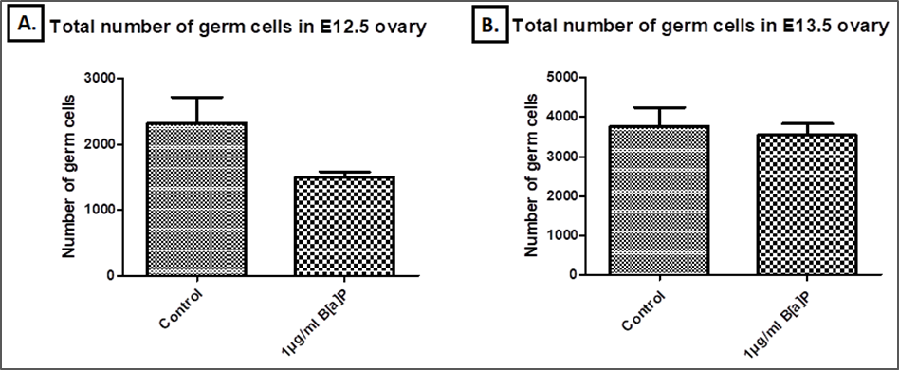
Figure 2. The total number of germ cells in the developing mouse ovary at A) E12.5 B) E13.5.

What do you conclude from your findings? (max 150 words)
We hypothesised that B[a]P reduces the rate of germ cell proliferation in the fetal ovary, however this is not supported by the findings of this study. We therefore conclude that any effect of B[a]P on the developing mouse ovary is not via germ cell proliferation immediately prior to follicle formation.

How has this experience influenced your thinking regarding your future/ongoing studies, and/or career choice? (max 150 words)
Undertaking this summer project and working alongside professional reproductive biologists in the Spears lab gave me a great opportunity to experience academic research and strengthened my desire to pursue further postgraduate study in the field of reproduction and fertility. I now feel much more confident working in a laboratory environment leading me to choose a lab-based Honours project in which I will surely be able to utilise the practical research skills that I gained. Additionally, this project allowed me to improve my literature searching, experimental design as well as data analysis and presentation skills, further preparing me for a career in science. I am also delighted to be presenting this project at Fertility 2019, which is an exceptional opportunity to get as an undergraduate student!

Please use the space below to add any other comments/thoughts about the SRF Vacation Scholarship (max 100 words)
Student: I would like to thank SRF for awarding me with this Vacation Scholarship. It allowed me to fully dedicate myself to exploring my research interests and developing valuable skills without having to worry about my living costs or lab expenses associated with the project.
Supervisor: Magda was an excellent student who got on extremely well in what is a short period of time: we were very happy to have her in the laboratory. She worked carefully in the laboratory, and more importantly could think clearly about her results and what they meant. I’m sure that it was disappointing for her to get a negative result, but she could also see that this nonetheless moved the work forward, now allowing us to discount one hypothesis and move on to examine others. Overall, Magda is someone who takes naturally to the research process and will do well if she decides to take that route.

