SRF Vacation Scholarship report 2018 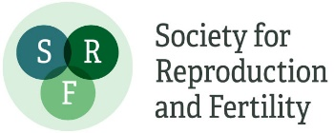

The form below should be completed by the student, then forwarded to the supervisor for approval and submission to srf@conferencecollective.co.uk within 8 weeks of completing the project. Please submit the form as a Word document.

A maximum of one figure (with legend of less than 100 words) may be appended if required.

Please note: excerpts from this form may be published on the SRF website, so please ensure content is suitable for website publication, and does not compromise future dissemination of data in peer-reviewed papers etc. The SRF reserves the right to edit responses to ensure suitability for publication on the website, newsletter or in promotional material.

Student’s Name: | Laura Copley | Student’s Institution/University: | University of Nottingham
Degree Title and year of study: | Veterinary Medicine and Science – year 3.
Supervisor’s Name: | Dr Bob Robinson | Supervisor’s Department and Institution: | Veterinary Medicine and Science, University of Nottingham
Project Title: | The impact of endometritis on luteal function in the cow

Briefly outline the background and aims of the project (max 200 words)
Reproductive health is central to the health, welfare and productivity of the dairy cow and herd. However, uterine microbial disease affects up to half of all dairy cattle after parturition, causing infertility by disrupting uterine and ovarian function. It has a major economic impact by increasing calving interval, services per conception, culling rates and decreasing milk yield. In the laboratory, the effect of systemic infection on the reproductive tract may be faithfully mimicked by treating bovine ovarian cells with the bacterial endotoxin lipopolysaccharide (LPS).
Ovarian endothelial cells are exquisitely sensitive to LPS treatment, resulting in a 95% reduction in endothelial cell network formation in vitro. This anti-angiogenesis effect occurs in response to pathologically-relevant LPS doses and despite the presence of pro-angiogenic factors. Interestingly, this effect on the ovary is in sharp contrast to the angiogenic stimulatory effects of LPS in other organs. More importantly, our novel in vitro findings are mirrored in vivo; dairy cows with endometritis have reduced luteal vascularization concomitant with a reduction in steroidogenesis. The project is designed to increase our understanding of how LPS adversely effects the corpus luteum (CL)
The bovine CL expresses all toll-like receptors (TLR) (pattern recognition receptors that mediate innate immune responses) including TLR4 through which LPS acts. The intracellular signaling following TLR4 activation include the NFKB, JNK and IRF3 pathways.

Aims:
- To confirm that LPS exerts its adverse effect on luteal endothelial cells via TLR4
- To determine the potential intracellular pathways through which LPS is acting through the blockade of specific pathways.

Did the project change from that proposed in the application? If so, what changes were made and why? (max 100 words)
In the initial experiments, the cells were treated with various signaling inhibitors from day 1 to 5 of culture. However, the treatment had a cytotoxic effect. Thus, the design had to be adjusted such a lower dose of the inhibitors was used and for a shorter time. Collectively, this meant that fewer “proper” cultures were completed. In addition, I used the wrong chemical to fix the cells causing the plastic wells to melt, which rendered the cells unusable for immunohistochemistry. This meant that the data produced was more preliminary than we had planned.
What were the main results/findings of the project? (max 300 words)
In agreement with previous experiments in the laboratory, LPS drastically reduced the formation of endothelial cell (EC) networks (p<0.001). This effect was reversed with the inclusion of a TLR4 inhibitor (TAK242) (p<0.01 vs LPS) such EC networks were formed to a similar extent as the control. In a follow-up experiment, cells were treated with LPS (100ng/ml) on days 1 to 3 of culture or on days 3 to 5 of culture. In this experiment, progesterone output in the spent media was measured. The production of progesterone increased 2-fold from day 3 to 5 of culture (p<0.05) mimicking the post-ovulatory progesterone rise. However, no effects of LPS or day x LPS interaction (p>0.05) were detected (n=4; Table 1).
Table 1: Mean±SEM of progesterone production in bovine luteal cells treated with LPS (n=4)
Day of culture | no LPS | LPS (100ng/ml)
3 | 677.7±190.4 | 617.4±159.6
5 | 1534.9±244.2 | 1102.7±124.6

In the main experiment, we investigated the effect of different signaling inhibitors on control and LPS-treated luteal cells. The purpose of this, was to determine the mechanism by which LPS was exerting its negative effect on endothelial cells. The inhibitors were BAY-11-7082 which inhibits the transcription factor, NFKB; SP600125 which inhibits JNK; SB505124 which disrupts TGFB signaling and a TNFA inhibitor. Unfortunately, insufficient cultures were immunostained for von Willebrand factor to perform image and data analysis. In the absence of LPS, TGFB and TNFA inhibitors appeared to slightly reduce the EC network. As expected, EC networks were decreased with LPS treatment (Fig 1A-F), however when co-treated with either SB505124 or TNFA inhibitor then the EC networks appeared to be increased. In respect to progesterone production (n=2 cultures), in agreement with the previous experiment LPS had no effect on progesterone production. However, it was decreased 8-fold by BAY-11-7082, 5-fold by SP600125 and TNFA inhibitor in the absence and presence of LPS. In contrast treatment with SB505124 had no effect.
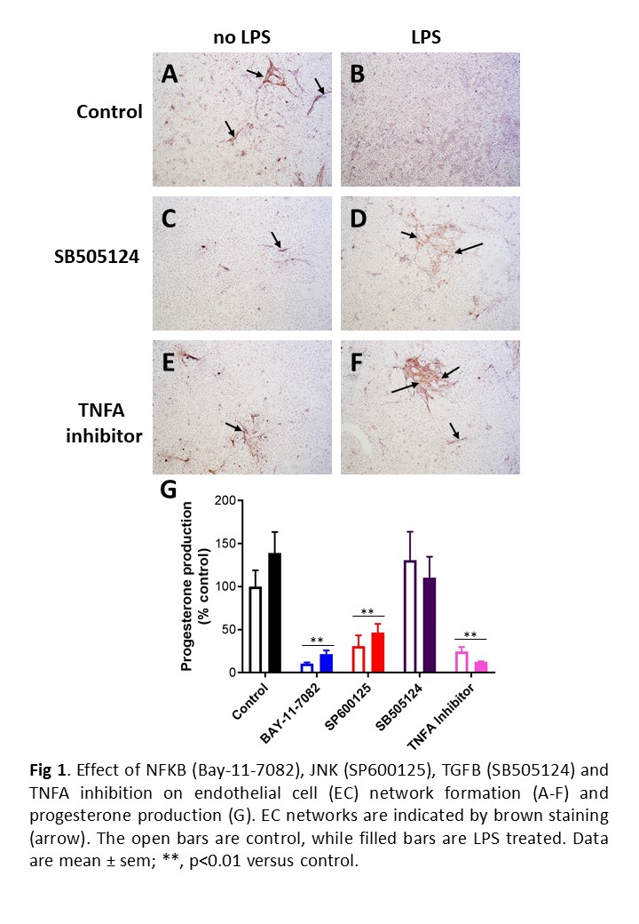

What do you conclude from your findings? (max 150 words)
LPS acting through TLR4 reduced the formation of endothelial cell networks in bovine luteal cells. However, LPS had no effect on the ability of these cells to progesterone, which increased over time in culture.
Inhibition of TGFB and TNFA signaling reduced endothelial cell network formation and appeared to reverse the effects of LPS. This observation though requires further validation.
Inhibition of NFKB and JNK pathways as well as TNFA signaling inhibited progesterone production by bovine luteal cells.

How has this experience influenced your thinking regarding your future/ongoing studies, and/or career choice? (max 150 words)
This research project has been amazing. I have developed so many skills and gained confidence in my capabilities. I have enjoyed the responsibility of running experiments within a lab. Learning the reasoning behind each stage of the method, which has shown me the importance of much more carefully and thus allowing me to achieve the best results possible.
I was welcomed into the research team and have found it fascinating to see how effectively they work. I also now admire and appreciate the hours that researchers have to put in to achieve success.
Bob has given me an inside as to how it feels to work in a university and what is expected of you. Listening to Bob and watching the lecturers work showed me how dedicated you have to be and I feel I would only suit doing research projects occasionally rather than as a full time job. I do however want to do another research project in my next summer vacation as I could not have learnt some of the skills I have any other way. I am much more competent working in the lab and have far more confidence in talking to lecturers and seeking help.

Please use the space below to add any other comments/thoughts about the SRF Vacation Scholarship (max 100 words)
Student: I would recommend this project to anyone looking to develop lab skills (although you do develop much more). I have done around 36 weeks’ worth of placement and none of them have taught me half as much as this one. You will be challenged and you will learn much more if you are ready to put lots of effort in. This scholarship has provided me with a great opportunity to do research in a very interesting field and also the chance to present work at a conference. I would never have been given this opportunity without the SFR scholarship.

Supervisor: It was a great opportunity to supervise Laura during her SRF vacation scholarship. It was an invaluable experience for her and she developed both technically and professionally. I wish to thank the SRF for giving her this opportunity as it gives students a fantastic insight into reproductive biology research.

`

