SRF Vacation Scholarship report 2018

The form below should be completed by the student, then forwarded to the supervisor for approval and submission to srf@conferencecollective.co.uk within 8 weeks of completing the project. Please submit the form as a Word document.

A maximum of one figure (with legend of less than 100 words) may be appended if required.

Please note: excerpts from this form may be published on the SRF website, so please ensure content is suitable for website publication, and does not compromise future dissemination of data in peer-reviewed papers etc. The SRF reserves the right to edit responses to ensure suitability for publication on the website, newsletter or in promotional material.

Student’s Name: | Aniruddha Voruganti | Student’s Institution/University: | University of Oxford
Degree Title and year of study: | Pre-clinical medicine, Year 3
Supervisor’s Name: | Dr. John Parrington | Supervisor’s Department and Institution: | Department of Pharmacology, Oxford
Project Title: | To study the expression of PLC isoforms in WT vs PLCζ KO mouse ovarian tissue using Western Blots.

Briefly outline the background and aims of the project (max 200 words)
Mammalian oocyte activation is characterised by a series of Ca²⁺ (from ER via InsP₃Rs) oscillations at fertilization. Parrington et al. identified a novel sperm PLC, PLCζ, as an agent of oocyte activation involved in Ca²⁺ release. Injecting recombinant PLCζ into oocytes triggers Ca²⁺ oscillations mimicking those observed at fertilisation, and immunodepletion of PLCζ from sperm extracts abolishes their ability to trigger Ca²⁺ oscillations. Dr. Parrington’s lab has created PLCζ knockout mouse lines using CRISPR/Cas9. Analysis showed that sperm from these PLCζ KO males lacked PLCζ and failed to produce Ca²⁺ oscillations following ICSI, supporting the idea that PLCζ is the source of the Ca²⁺ oscillations after ICSI. (Hachem, Godwin et al. 2017). Long term, PLCζ males fathered fewer offspring, and there was increased polyspermy both in vitro and in vivo. However according to recent unpublished results from Dr. Parrington’s lab, surprisingly, oocytes that were fertilised by IVF with fresh PLCζ KO sperm showed delayed (~ 1 hour) secondary Ca²⁺ oscillations. Cryopreserved PLCζ KO sperm did not induce these secondary transients in the oocytes (Swann and Parrington, unpublished). They propose the existence of an alternative ‘ancient’ oocyte activating factor, which may interact with PLCζ release to generate Ca²⁺ oscillations.
Did the project change from that proposed in the application? If so, what changes were made and why? (max 100 words)
The project outlined in the application was of a very vast scope, and hence I was able to focus on a small part of the proposed project, namely, comparing the expression of PLC isoforms in mouse ovarian tissue. We were hoping to see whether there were compensatory changes of PLC expression corresponding to the changes in PLC expression in sperm.
What were the main results/findings of the project? (max 300 words)
I began by learning to extract mouse ovarian tissue, homogenize it and extract the protein. I then performed BCA assays to assess concentration for the Westerns.
Concerning PLCB1 expression in WT vs KO ovary, the following RT-PCR results are below:
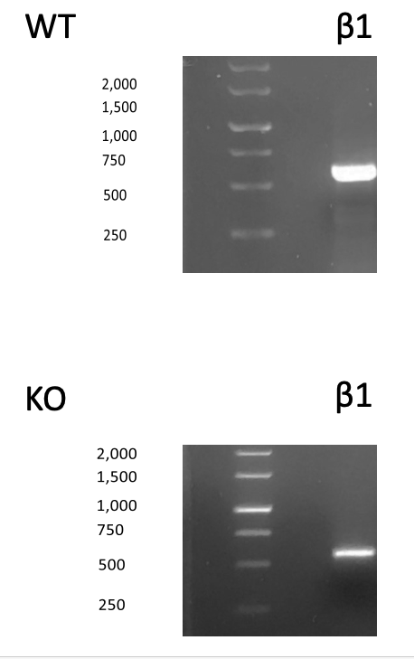
Western Blot Image:
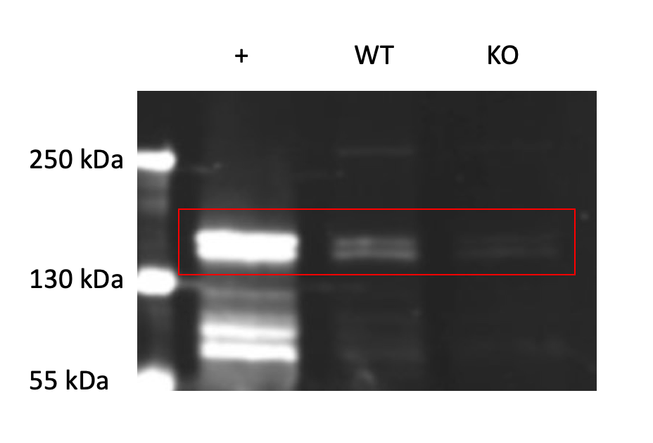
As can be seen, there is a reduction in PLCB1 transciption in PLCZ KO mouse ovarian tissue. There does not appear to be a compensatory increase in PLCB1 expression in PLCZ KO ovaries.
My project mainly involved performing several Western Blots, the results for PLCB1 are shown in the image above. However, the rest of the PLCs I studied did unfortunately did not show meaningful results. The main PLCs I worked on were PLCB1, PLCB2, PLCD3, PLCD4, and PLCG1. I spent a lot of time optimizing these blots by modifying my protocol in the following ways:
- By using new tissue and sample dilutions
- by using different primary and secondary antibodies
- by varying the time of incubation of membrane with the antibody solution
- by changing the concentrations of antibodies
- by using different gel plates
- by changing the concentrations of Tween and SDS, and the number of washes when the blots were not clear, and
- by varying the intensity of the light from the scanner.

What do you conclude from your findings? (max 150 words)
I believe the primary antibodies we used were potentially defective, or furthermore the method of homogenizing the tissue to extract protein was not appropriate. These were the two variables I did not have the time to change, and perhaps with more time I might have had some success.

How has this experience influenced your thinking regarding your future/ongoing studies, and/or career choice? (max 150 words)
I learnt a lot about how science is not always as easy as it seems on paper. Being my first lab project, I believe it was a very valuable lesson on how many times an experiment needs to be repeated before it works, and furthermore how this would need to be repeated several times to get scientifically valid results. While my experiments did not yield results, I am not disillusioned with science, since I enjoyed my time immensely - especially attempting to solve the problems I faced by changing one variable at a time.

Please use the space below to add any other comments/thoughts about the SRF Vacation Scholarship (max 100 words)
Student: I think my project under the SRF scholarship was an eye-opening experience on how science does not always go according to plan. I enjoyed it very much nonetheless, and am grateful for being given the opportunity to learn this lesson so early on in my career.

Supervisor: Ani worked very hard to optimize the analysis of protein expression in the ovaries of WT vs PLCzeta knockout mice. He has learned lots of useful new techniques and also valuable lessons about problem-solving in scientific studies.

